
COMSATS Institute of Information Technology (CIIT)
Islamabad Campus
CSC271 Database Systems
Assignment # 1
(Due Date: 10/04/2013)
For the following exercises, use the Hotel schema deﬁned below.

The following tables form part of a database held in a relational DBMS:
Hotel (hotelNo, hotelName, city)
Room (roomNo, hotelNo, type, price)
Booking (hotelNo, guestNo, dateFrom, dateTo, roomNo)
Guest (guestNo, guestName, guestAddress)

- Describe the relations that would be produced by the following relational algebra operations:
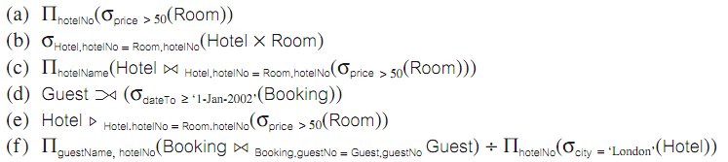
- Generate the relational algebra expressions for the following queries:
(a) List all hotels.
(b) List all single rooms with a price below £20 per night.
(c) List the names and cities of all guests.
(d) List the price and type of all rooms at the Grosvenor Hotel.
(e) List all guests currently staying at the Grosvenor Hotel.
(f ) List the details of all rooms at the Grosvenor Hotel, including the name of the guest staying in the room, if the room is occupied.
(g) List the guest details (guestNo, guestName, and guestAddress) of all guests staying at the Grosvenor Hotel.

For the following exercises, use the Hotel schema deﬁned below.

Branch (branchNo, street, city, postcode)
Staff (staffNo, fName, lName, position, sex, DOB, salary, branchNo)
PropertyForRent (propertyNo, street, city, postcode, type, rooms, rent, ownerNo, staffNo,
branchNo)
Client (clientNo, fName, lName, telNo, prefType, maxRent)
PrivateOwner (ownerNo, fName, lName, address, telNo)
Viewing (clientNo, propertyNo, viewDate, comment)
Registration (clientNo, branchNo, staffNo, dateJoined)

1. Generate the relational algebra expressions for the following queries:

- List the no. of clients who can pay maximum rent greater than 350.
- List all staff who works in branch located at city Amberden.
- List the number of clients who have registration after ‘April 03’.
- List all the properties that have been viewed by John Kay.
- List the number of clients who have viewed a property for rent.

